BÁO CÁO THỰC HÀNH LAB 2  
LẬP TRÌNH HƯỚNG ĐỐI TƯỢNG

**Table of Contents**

**1. Các nhánh trong github** 3

**2. Working with method overloading** 3

2.1. Overloading by differing types of parameters 3

2.2. Overloading by differing the number of parameters. 4

**3. Passing parameter** 4

**4. Use debug run** 5

**5. Classifier Member and Instance Member** 6

**6. Open the Cart class** 6

**7. Implement the Store class** 9

**8. Re-organize your projects** 10

**9. String, StringBuilder and StringBuffer** 12

**Table of figures**

Figure 1: Create some branches 3

Figure 2: Method to add a list DVD to cart. 3

Figure 3: Check method to add a list DVD. 4

Figure 4: Method to add 2 DVDs to cart. 4

Figure 5: Check method to add 2 DVDs. 4

Figure 6: Create java class named TestPassingParameter 5

Figure 7: Swap method and changeTitle method 5

Figure 8: Result for running TestPassingParameter 5

Figure 9: Create attrbute ID 6

Figure 10: Write a method toString() 6

Figure 11: Method to print 7

Figure 12: Result for printing the cart 7

Figure 13: Method to search by title 7

Figure 14: Method search by ID 8

Figure 15: Create getter and setter for ID 8

Figure 16: Result for finding DVD 8

Figure 17: CartTest class 8

Figure 18: Attribultes of the store class 9

Figure 19: Method addDigitalVideoDisc 9

Figure 20: Method removeDigitalVideoDisc 9

Figure 21: Method to caculate totalCost 10

Figure 22: The StoreTest Class 10

Figure 23: My project after reorganize 11

Figure 24: ConcatenationInLoops Class and result 12

Figure 25: GaebageCreator Class, result and change code 14

# **1. Các nhánh trong github**

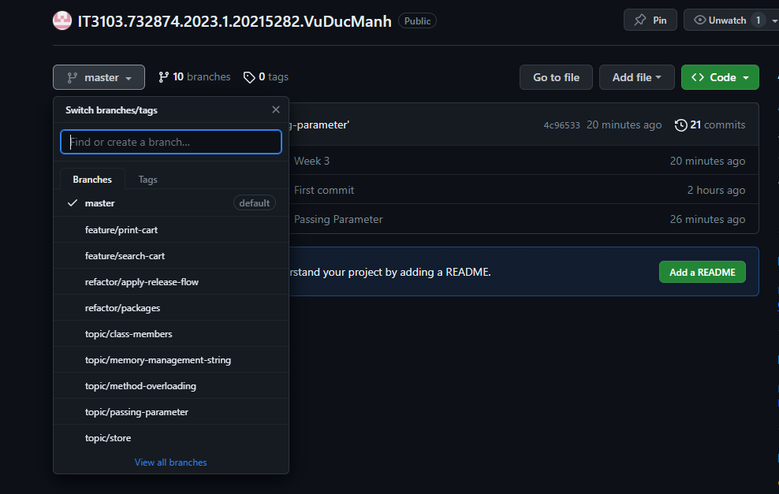

Figure 1: Create some branches

# **2. Working with method overloading**

## 2.1. Overloading by differing types of parameters

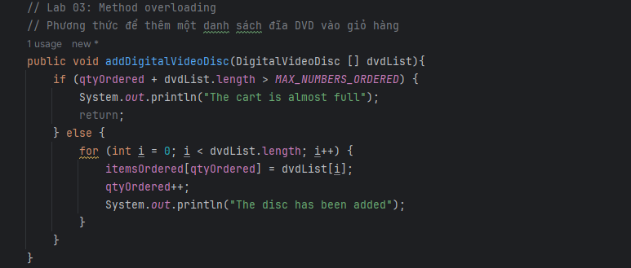

Figure 2: Method to add a list DVD to cart.

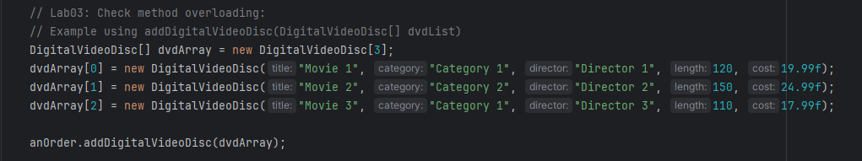

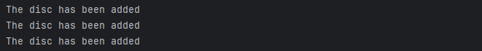

Figure 3: Check method to add a list DVD.

## 2.2. Overloading by differing the number of parameters.

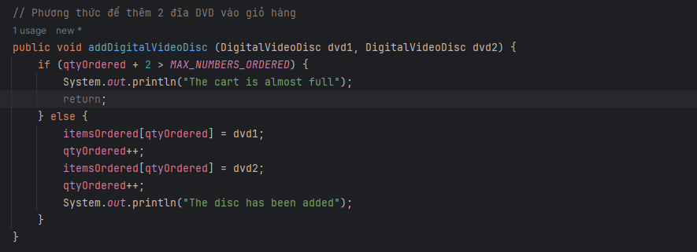

Figure 4: Method to add 2 DVDs to cart.

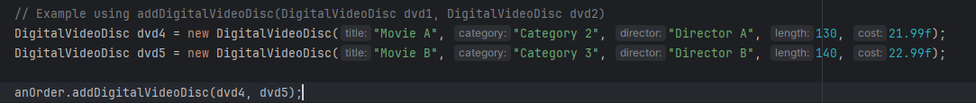

Figure 5: Check method to add 2 DVDs.



# **3. Passing parameter**

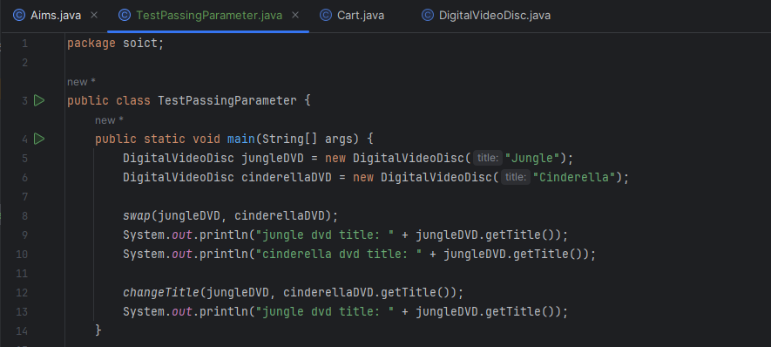

Figure 6: Create java class named TestPassingParameter

Figure 7: Swap method and changeTitle method

Figure 8: Result for running TestPassingParameter

# **4. Use debug run**

- Làm theo các bước trong hướng dẫn lab03:

* Setting, deleting & deactivate breakpoints
* Run in Debug mode
* Step Into, Step Over, Step Return, Resume
* Investigate value of variables
* Change value of variables

# **5. Classifier Member and Instance Member**

Figure 9: Create attrbute ID

# **6. Open the Cart class**

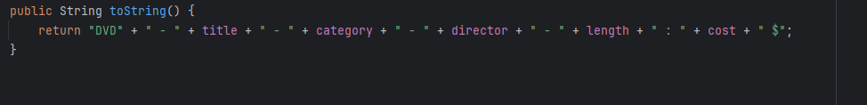

Figure 10: Write a method toString()

Figure 11: Method to print

Figure 12: Result for printing the cart

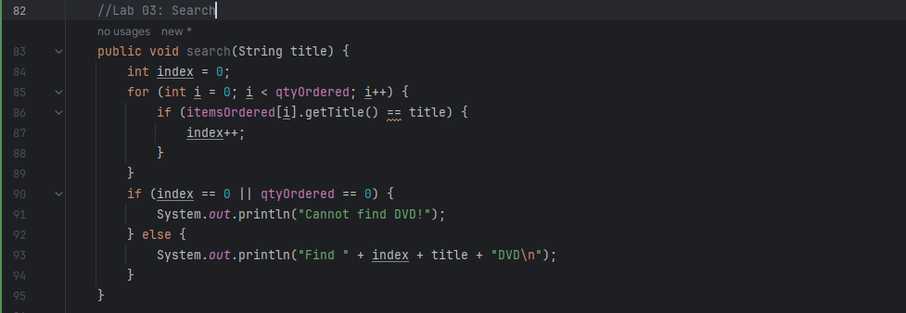

Figure 13: Method to search by title

Figure 14: Method search by ID

Figure 15: Create getter and setter for ID

Figure 16: Result for finding DVD

Figure 17: CartTest class

# **7. Implement the Store class**

Figure 18: Attribultes of the store class

Figure 19: Method addDigitalVideoDisc

Figure 20: Method removeDigitalVideoDisc

Figure 21: Method to caculate totalCost

Figure 22: The StoreTest Class

# **8. Re-organize your projects**

Figure 23: My project after reorganize

# **9. String, StringBuilder and StringBuffer**

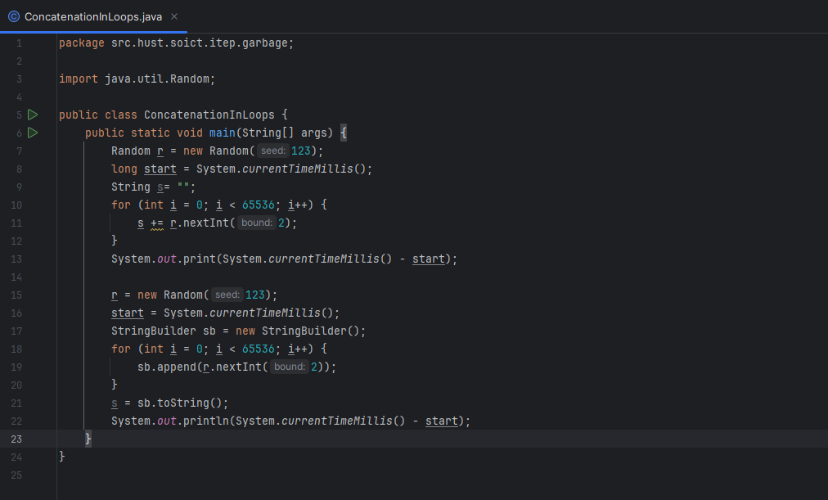

Figure 24: ConcatenationInLoops Class and result

Figure 25: GaebageCreator Class, result and change code